OMIS 324 Project

NBA’s Various Scoring Methods and Average Points per Game



Jimmy Mahoney(z1826166@students.niu.edu ), Brandon Townsend (Z1760198@students.niu.edu), Jose Coliz (z1777024@students.niu.edu), and Sidharth Raj (z1818309@students.niu.edu)

12/05/2018

**Introduction**

For this project, we decided to look at the NBA and if the amount of three point field goals in relation to the amount of two point field goals and free throws had an impact on the average points scored throughout a season. The main goal of our project was to see if a team averaged more three point field goals and had around the average percentage of shots made, they would score more points in total. Our dataset is based off of the website [www.basketball-reference.com](http://www.basketball-reference.com). Basketball-Reference is a database that stores data on the major basketball leagues in the world, including the league our project is on, the NBA.The dataset included statistics on everything there is to keep track of for a team, including total field goals, total rebounds, assists, turnovers, etc… dating back to the 2000-01 season. We focused our analysis around a select few variables:

1. 3P: Average amount three pointers made
2. 2P: Average amount two point field goals made
3. FT: Average amount free throws made
4. Season: The NBA season which was taking place

Taking everything into account, we came up with a hypothesis, we believed that when a team starts to make more three point shots, regardless of what happens with two point shots and free throws, they would begin to average more than previous seasons. Another hypothesis we came up with was that as teams began shooting more three point shots, the number of two point shots and with that, free throws, that were attempted would decrease. As we began sorting through the data, we began to notice a trend in the field goals made and total points scored.

**Part 1: Descriptive Analysis**

Once we found our set of data, we decided that it would be beneficial to just get a general feel for exactly what kind of data it is. Basketball-Reference’s website aggregated the data to contain the season averages for total points scored through the various methods such as 2 pointers, free throws, and 3 pointers. We also have data related to the season averages of field goals attempted through all those methods as well.

Figure 1: 3 Pointers, 2 Pointers and Free Throw Frequency and Total Points Accumulated

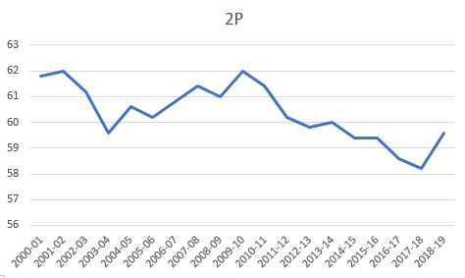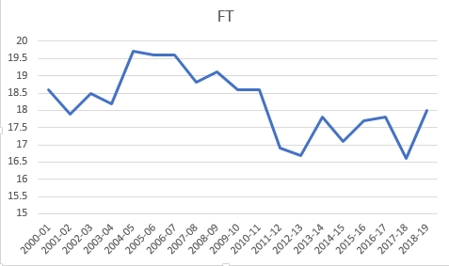

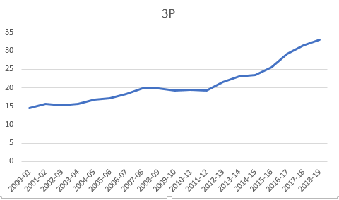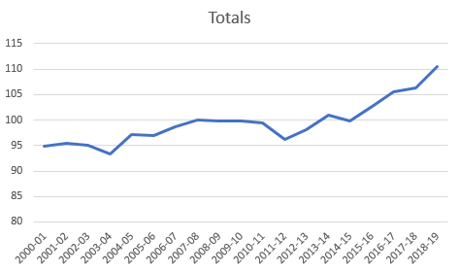

Figure 2: Frequency of 3 Pointes, 2 Pointers and Free Throws

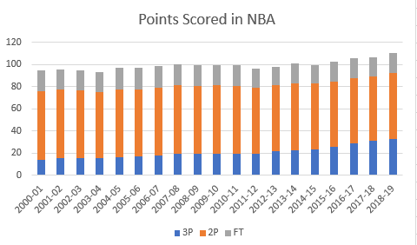

From the figures above, we can see that the concentration of point accumulation is mainly from 2 pointers. 3 pointers and free throws balance out in terms of contribution towards the total points as the frequency of 3 pointers is gradually increasing and the frequency of free throws fluctuates around a small range. A deduction can be made for the frequency of 2 pointers that is that it is easier to score due to rebound plays while there is more pressure involved when trying to score a 3 pointer or a free throw. An assumption to why 3 pointers are increasing gradually could be because basketball is currently becoming more competitive and much more talent is being recognized. This also explains why the frequency of scoring 2 pointers is reducing over time.

Figure 3: Descriptive Statistics of Data

|  |  |  |  |  |  |
| --- | --- | --- | --- | --- | --- |
| 3P |  | 2P |  | FT |  |
| Mean | 6.979 | Mean | 30.205 | Mean | 18.2 |
| Median | 6.5 | Median | 30.1 | Median | 18.2 |
| Standard Deviation | 1.820 | Standard Deviation | 0.584 | Standard Deviation | 0.952 |
| Sample Variance | 3.313 | Sample Variance | 0.341 | Sample Variance | 0.907 |
| Kurtosis | 0.233 | Kurtosis | -0.508 | Kurtosis | -0.772 |
| Skewness | 1.020 | Skewness | -0.011 | Skewness | -0.091 |
| Range | 6.2 | Range | 2.2 | Range | 3.1 |
| Minimum | 4.8 | Minimum | 29.1 | Minimum | 16.6 |
| Maximum | 11 | Maximum | 31.3 | Maximum | 19.7 |

The data in figure 2 was retrieved through the data analysis tool in Excel. From the data, we find 3 pointers to have a positive skewness exceeding 1 suggesting that the data has a high degree of skewness. Moving forward, the data for 2 pointers and free throws are negatively skewed but between the range of 0.5 and 1 suggesting that the data is only moderately skewed. From the mean and median of all three scoring methods, we find that the average frequency of scoring a 3 pointer or 2 pointer or free throw over the years is not influenced by any outliers. Apart from that, the kurtosis of all three scoring methods are below 3 which indicates that the data is somewhat flat with a wide degree of dispersion.

**Part 2: Regression Analysis**

**Part 2a: Three pointers and Total Points scored**

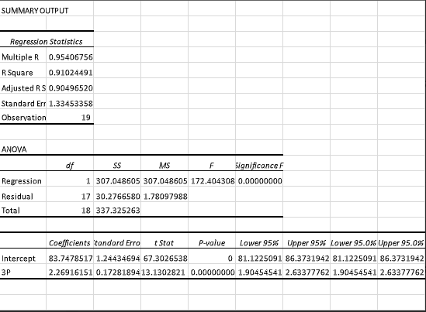

This regression model shows the relationship between three pointers made and total points scored. Once looking at the model we can see that the R-Square value is right around 91%. This high of a R-Square value is proof of how there is a strong correlation between the amount of three pointers made and amount of points scored. Another indicator of the relationship is the p-value, which is considerably less than 0.05. This is something that we anticipated at the beginning when coming up with our hypothesis.

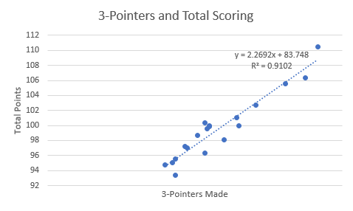

This graph shows the visual representation of the regression model including the R-Square value and the equation of the line. We can also tell from the data points and the trend line on the graph that these two variables show not only a strong correlation, but also a positive linear relationship.

**Part 2b: Two Pointers and Total Points scored**

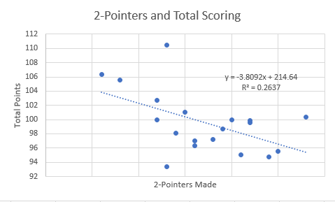

Our second regression model was to determine how strong or weak the relationship between two pointers and total points. The R-Square value is a low 26.37%, meaning that there is not a very strong correlation between these two variables. Unlike the three pointers model, this is showing that there is a negative linear correlation between them.

**Part 2c: Free Throws made and Total Points scored**

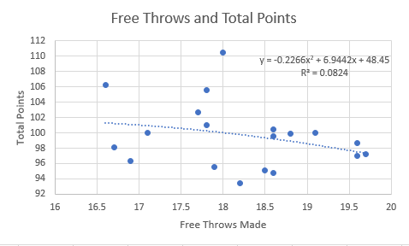

Our third and final regression model we made was for free throws made and total points scored. This model was not surprising at all to us, considering the small amount of free throws that are actually attempted and scored in a game. Less than 20 free throws has very little effect in the total points when on average it is around 100. We confirm this by looking at the R-Square value which is very low at .0824 or 8.24%. Based on the three regression models we did, free throws ended up having the lowest impact of total points.

**Part 3: Forecasting**

Figure 8: Forecasts of 3 Pointer, 2 Pointer, Free Throw and Total Points

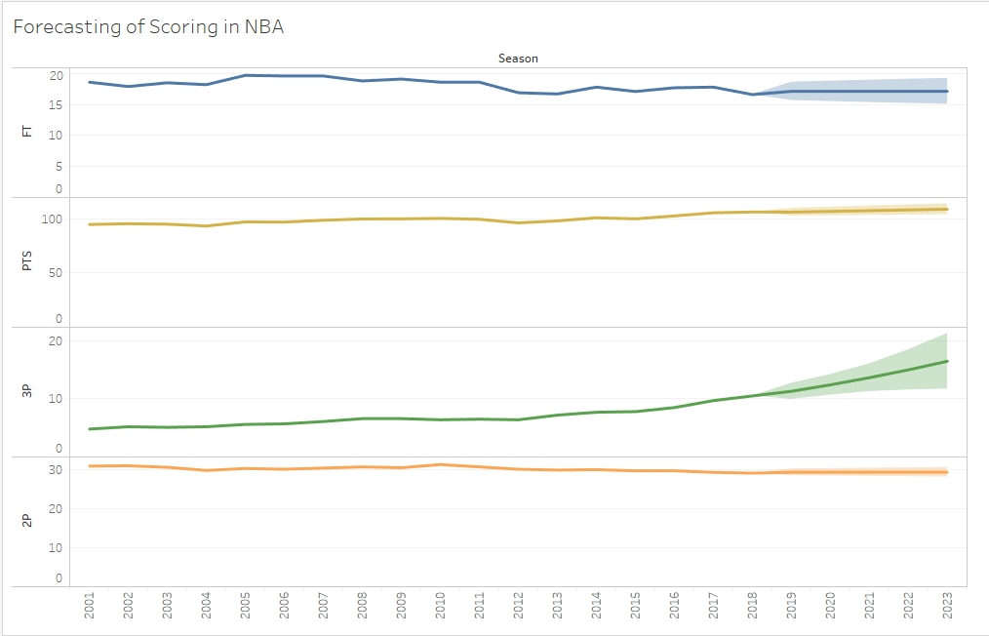

Figure 8 shows how the frequency of 3P, 2P and FT and Total Points will move in the future. The highlighted region represents the range of how much the frequency could potentially fluctuate. Based on the forecasted frequency of scoring 3 pointers, we can see that the rate of scoring a 3 pointer will continue to increase over time in the future. However, 2 pointers and free throws are forecasted to be stagnant with a bigger range of fluctuation for free throws.

Figure 8a: Forecasts of Types of Shots Attempted

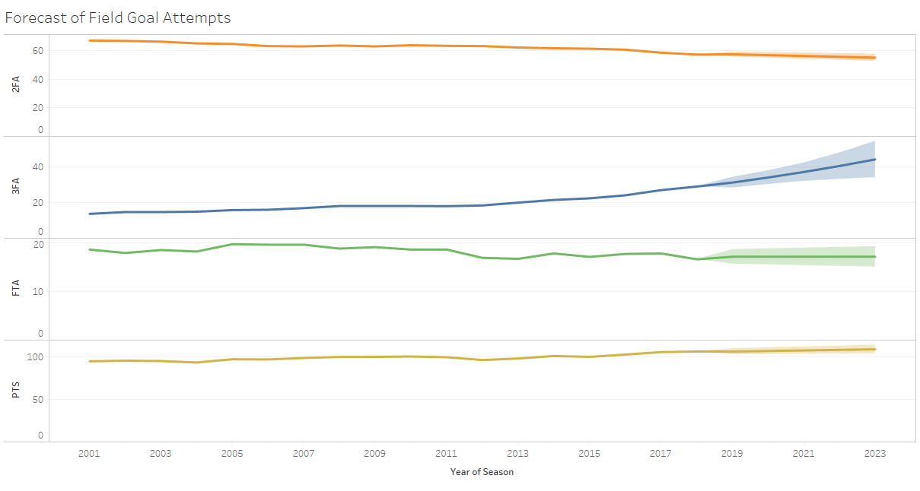

Figure 8a is very similar to Figure 8 in terms of how the forecasts see the future seasons in the NBA playing out. There seems to be a clear focus on increasing the number of 3 point shots attempted, whereas free throws and 2 point shots will see a very slight decline in attempts.

**Part 4: Conclusion**

Our group used various statistical analysis techniques like the basic descriptive analysis, regression models, and also forecasting techniques to come to conclusions about the NBA’s methods of scoring. After thorough analysis, it is clear that the various coaching staff around the NBA is putting a heavy focus on 3 point shooting when it comes to producing higher outputs of points. When our group started this project, we had a small inkling of an idea that 3 point field goal attempts were increasing over the past few seasons due to the way the NBA was changing rules for their league. However, we were quite surprised when we found out that during our regression analysis that the R-square value would be so different for 3 pointers and 2 pointers/free throws. Our regression analysis also showed how little of a correlation there is between 2 pointers and free throws there are with total scoring.

With this data and analysis, we came up with a few recommendations if new coaching staff that is hoping to work in the NBA could possibly use. Players that are being currently scouted should be proficient not only in an athletic view, but also at their 3-point shooting ability. Teams that are also focusing on a more physical type of basketball that uses 2-point shots more often should slowly start to move over to 3-point shooting being the focal point of their offense. By focusing on these 3-point shot attempts, they can expect to score more points per game, and thereby win more games overall.